LAB1

1. **Install CentOS /RHEL Done**
2. **What is the difference between cat and more command?**

cat displays the entire contents of the file at once.

more displays the file contents one screen at a time, allowing you to navigate through the

content using the spacebar or other specified keys.

1. **What is the difference between rm and rmdir using man?**

“rm” When you want to remove files or directories and their contents .

“use rmdir” to delete empty directories.

1. **Create the following hierarchy under your home directory:**
   1. **Remove dir11 in one-step. What did you notice? And how did you overcome that?**
   2. 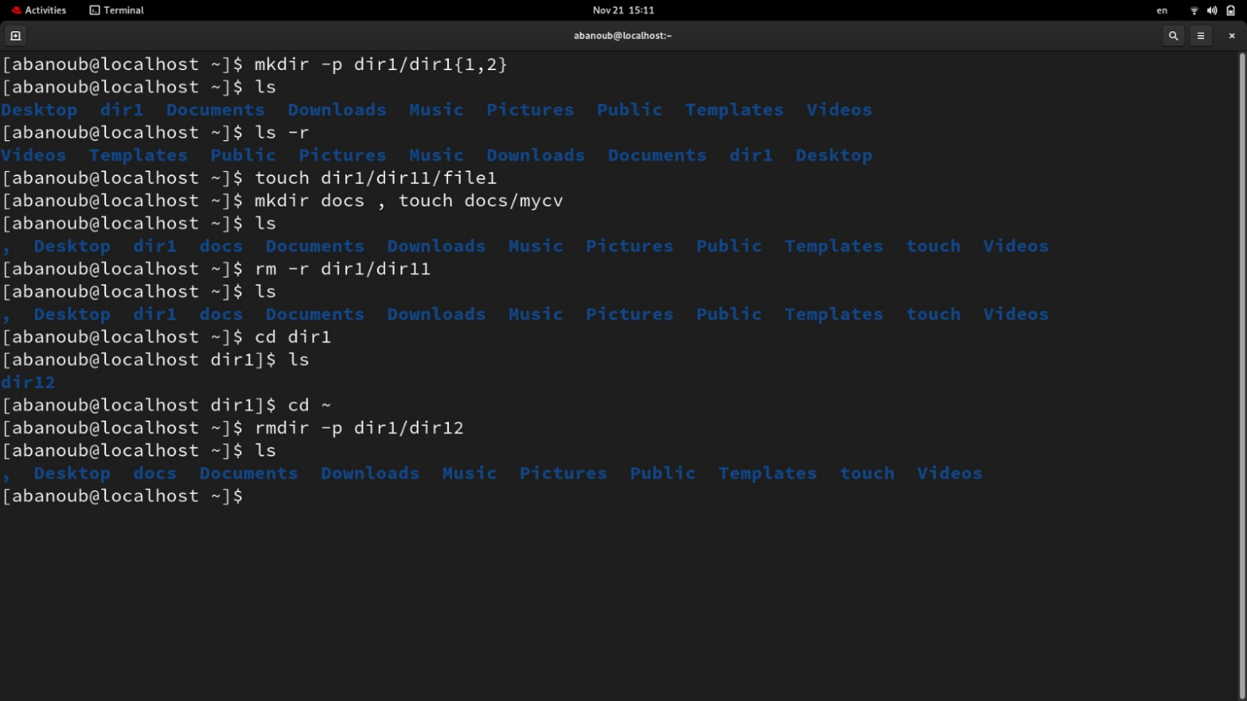**Then remove dir12 using rmdir –p command. State what happened to the hierarchy (Note: you are in your home directory).**
   3. **The output of the command pwd was /home/user. Write the absolute and relative path for the file mycv**

Absolute : /home/user/docs/mycv

Relative : ./docs/mycv

1. **Copy the /etc/passwd file to your home directory making its name is mypasswd.**
2. **Rename this new file to be oldpasswd.**

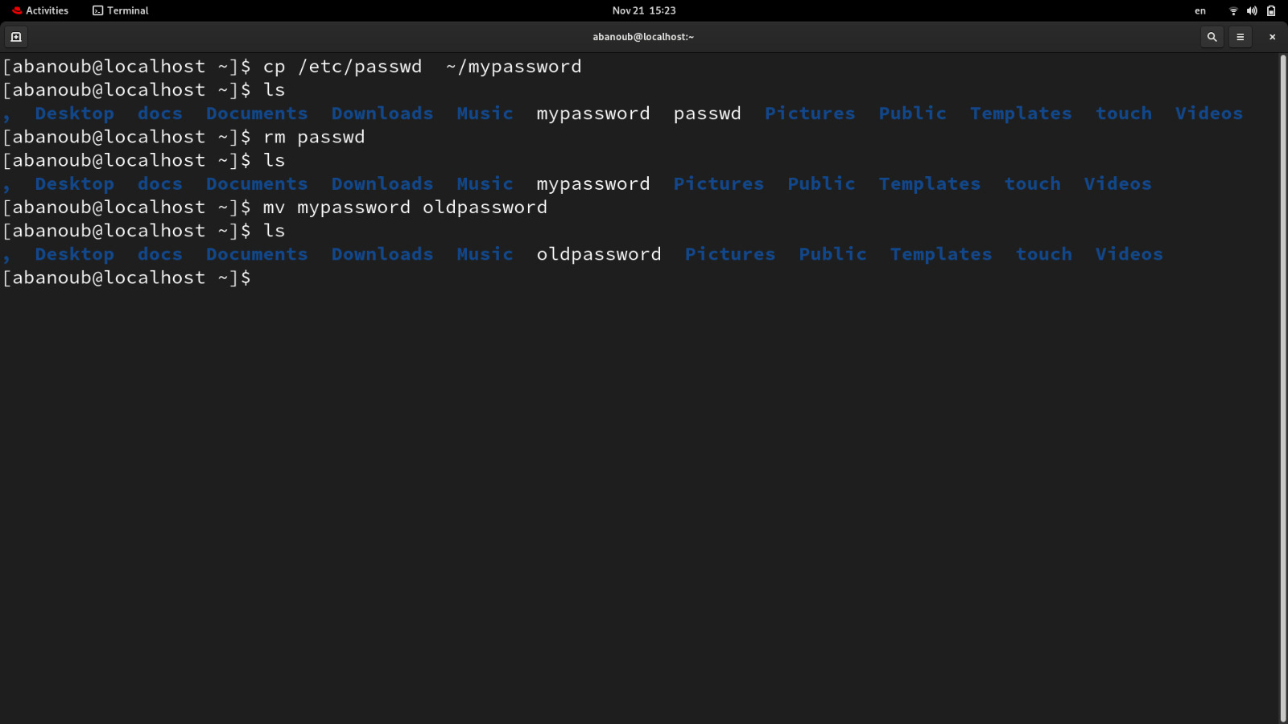

1. **You are in /usr/bin, list four ways to go to your home directory**
2. Cd ~
3. cd .. cd..
4. cd
5. cd /home/abanoub
6. **List Linux commands in /usr/bin that start with letter w**

ls “w*”

1. **Display the first 4 lines of /etc/passwd**
2. **Display the last 7 lines of /etc/passwd**

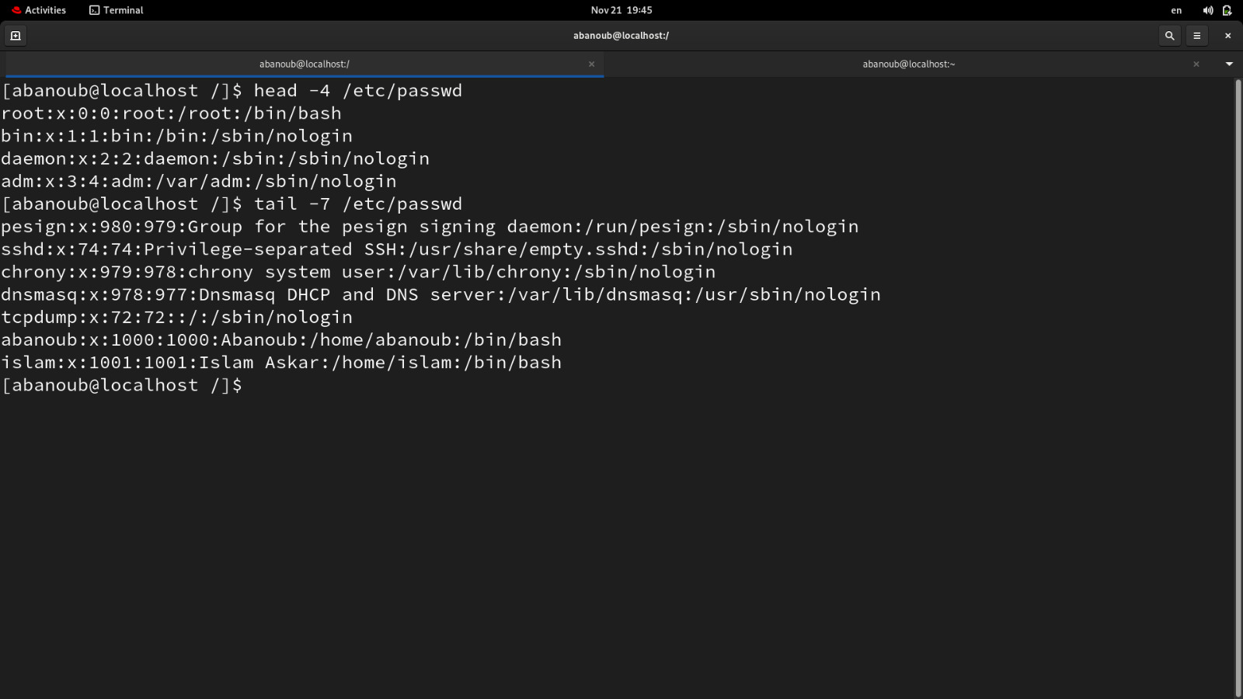

1. **Display the man pages of passwd the command and the file sequentially in one command.**

man –a passwd

**12.Display the man page of the passwd file.**

man 5 passwd

**13.Display a list of all the commands that contain the keyword passwd in their man page.**

man –k passwd